EXPERIMENT -1B
Name:- K.Mugunthan
Reg. No. :- 192512236
Program Code:
clc;
clear;
close all;
%% QUESTION B: TE10 VERSUS TM11 MODE
% WR-90 Rectangular Waveguide
a = 22.86e-3; % Width (m)
b = 10.16e-3; % Height (m)
L = 100e-3; % Length (m)
f = 10e9; % Operating frequency (Hz)
c = 3e8; % Speed of light (m/s)
mu0 = 4*pi*1e-7;
eps0 = 8.854e-12;
omega = 2*pi*f;
k0 = 2*pi*f/c;
%% 1. CUTOFF FREQUENCIES
% TE10 mode
fc_TE10 = c/(2*a);
% TM11 mode
fc_TM11 = (c/2)*sqrt((1/a)^2 + (1/b)^2);
fprintf('\n--- CUTOFF FREQUENCIES ---\n');
fprintf('TE10 cutoff frequency = %.4f GHz\n',fc_TE10/1e9);
fprintf('TM11 cutoff frequency = %.4f GHz\n',fc_TM11/1e9);
%% 2. PROPAGATION CONSTANTS

% TE10 propagation constant
if f > fc_TE10
beta_TE10 = k0*sqrt(1-(fc_TE10/f)^2);
else
beta_TE10 = 0;
end
% TM11 propagation constant
if f > fc_TM11
beta_TM11 = k0*sqrt(1-(fc_TM11/f)^2);
else
beta_TM11 = 0;
end
fprintf('\n--- PROPAGATION CONSTANTS ---\n');
fprintf('TE10 beta = %.4f rad/m\n',beta_TE10);
fprintf('TM11 beta = %.4f rad/m (real propagation)\n',beta_TM11);
%% 3. WAVEGUIDE COORDINATES
Nx = 100;
Ny = 80;
Nz = 100;
x = linspace(0,a,Nx);
y = linspace(0,b,Ny);
z = linspace(0,L,Nz);
[X,Y] = meshgrid(x,y);
%% 4. TE10 ELECTRIC FIELD DISTRIBUTION
Ey_TE10 = sin(pi*X/a);
figure(1);
surf(X*1000,Y*1000,Ey_TE10,'EdgeColor','none');
colorbar;

xlabel('Width x (mm)');
ylabel('Height y (mm)');
zlabel('Normalized Ey');
title('TE10 Electric Field Distribution');
view(45,30);
grid on;
%% 5. TE10 MAGNETIC FIELD DISTRIBUTION
Hx_TE10 = -beta_TE10/(omega*mu0)*sin(pi*X/a);
Hz_TE10 = -pi/(omega*mu0*a)*cos(pi*X/a);
H_TE10 = sqrt(Hx_TE10.^2 + Hz_TE10.^2);
figure(2);
surf(X*1000,Y*1000,H_TE10,'EdgeColor','none');
colorbar;
xlabel('Width x (mm)');
ylabel('Height y (mm)');
zlabel('|H| (A/m)');
title('TE10 Magnetic Field Distribution');
view(45,30);
grid on;
%% 6. TM11 ELECTRIC FIELD DISTRIBUTION
Ez_TM11 = sin(pi*X/a).*sin(pi*Y/b);
figure(3);
surf(X*1000,Y*1000,Ez_TM11,'EdgeColor','none');
colorbar;
xlabel('Width x (mm)');
ylabel('Height y (mm)');
zlabel('Normalized Ez');
title('TM11 Longitudinal Electric Field Distribution');
view(45,30);

grid on;
%% 7. TM11 MAGNETIC FIELD DISTRIBUTION
% Normalized spatial field pattern for TM11
% Valid as a cross-sectional pattern below cutoff;
% it is not a propagating-wave solution at 10 GHz.
Hx_TM11 = (pi/(omega*mu0*b))*cos(pi*X/a).*sin(pi*Y/b);
Hy_TM11 = -(pi/(omega*mu0*a))*sin(pi*X/a).*cos(pi*Y/b);
H_TM11 = sqrt(Hx_TM11.^2 + Hy_TM11.^2);
figure(4);
surf(X*1000,Y*1000,H_TM11,'EdgeColor','none');
colorbar;
xlabel('Width x (mm)');
ylabel('Height y (mm)');
zlabel('|H| (A/m)');
title('TM11 Magnetic Field Pattern');
view(45,30);
grid on;
%% 8. COMPARISON OF CUTOFF FREQUENCIES
figure(5);
bar([fc_TE10 fc_TM11]/1e9);
set(gca,'XTickLabel',{'TE10','TM11'});
ylabel('Cutoff Frequency (GHz)');
title('TE10 versus TM11 Cutoff Frequency');
grid on;
%% 9. MODE PROPAGATION DECISION
fprintf('\n--- MODE COMPARISON ---\n');
if f > fc_TE10
fprintf('TE10: PROPAGATES at 10 GHz.\n');
else

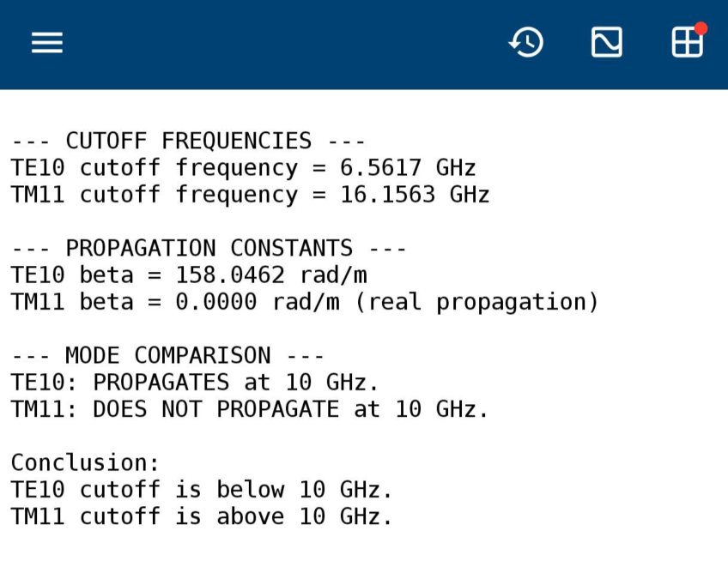

fprintf('TE10: Below cutoff.\n');
end
if f > fc_TM11
fprintf('TM11: PROPAGATES at 10 GHz.\n');
else
fprintf('TM11: DOES NOT PROPAGATE at 10 GHz.\n');
end
fprintf('\nConclusion:\n');
fprintf('TE10 cutoff is below 10 GHz.\n');
fprintf('TM11 cutoff is above 10 GHz.\n');
OUTPUT

